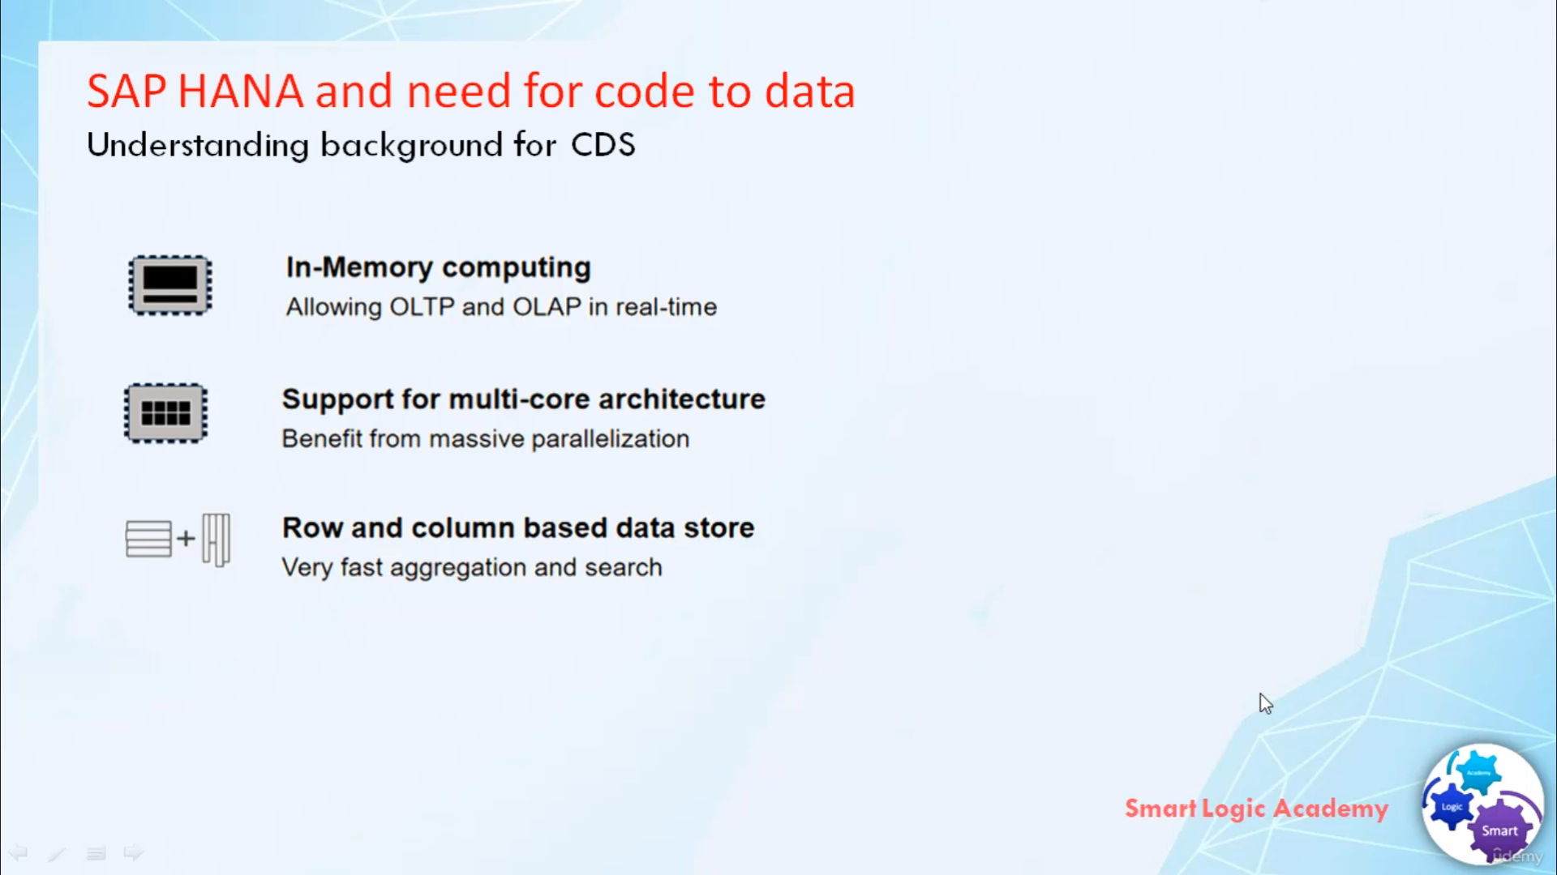

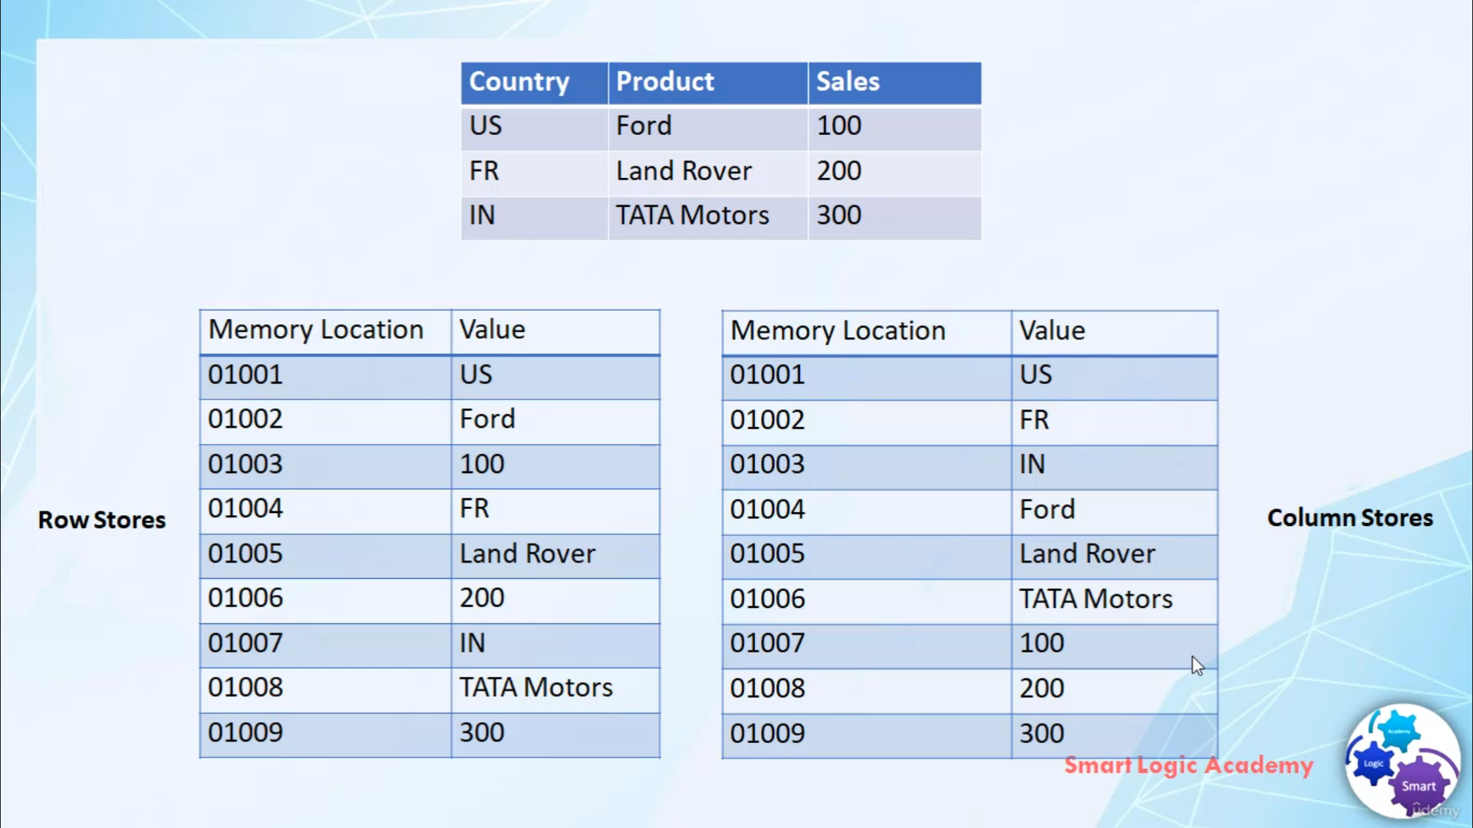

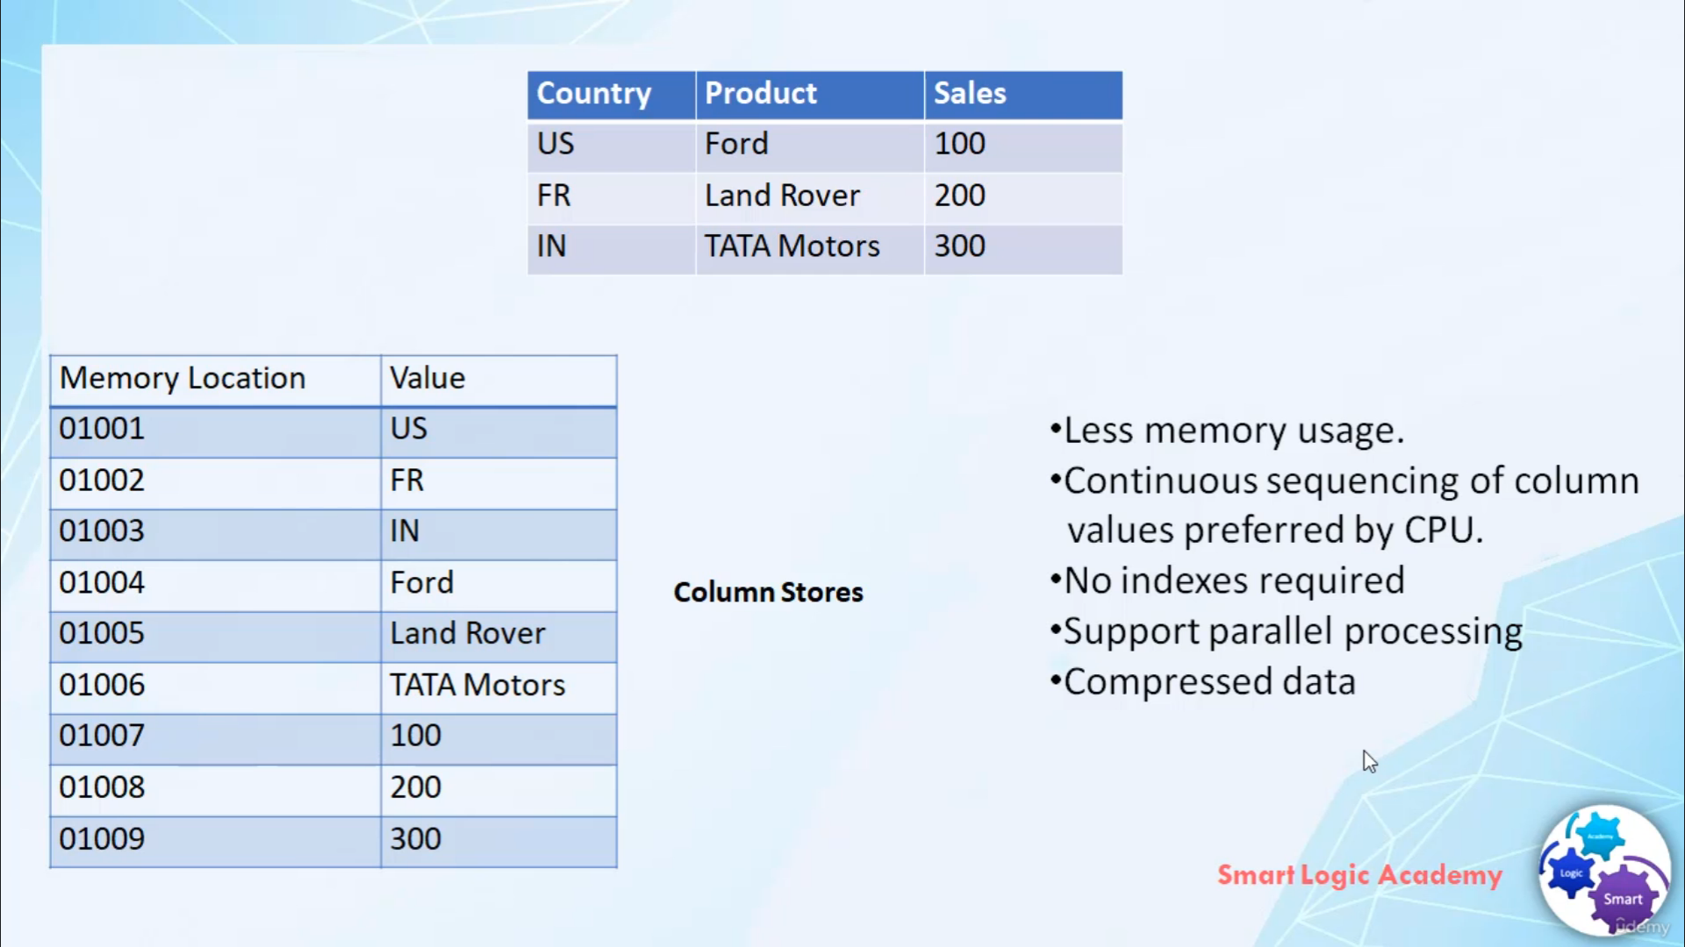

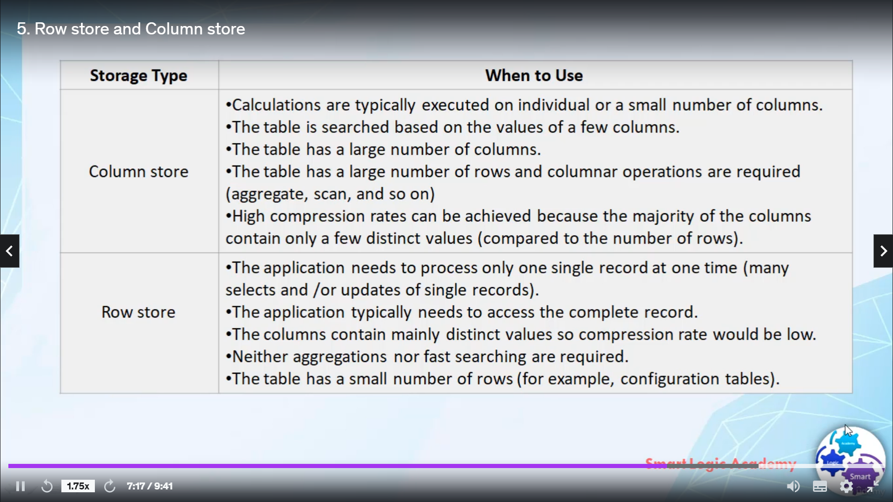

In this video, I will discuss with you about the very important feature of SAP HANA and that is nothing but row and column based data store.

So let's start

SAP HANA database supports two types of storage type ROW store and COLUMN Store

conceptually

a database table is a two-dimensional data structure with cells organized in rows and columns, whereas

a computer memory is organized as a linear sequence. hence for storing the table in linear memory

we have two options

one is ROW store

and another is a COLUMN store. In ROW store, it stores a sequence of records that contains the fields of one

row in the table.

in COLUMN store, the entire columns are stored in contiguous the memory locations.

ROW stores are designed to efficiently return data for an entire row or record, these matches

the common use case where the system is attempting to retrieve information about a particular object

for example in our case, let's say we want to find sales information in country France.

That means we want to fetch the entire record entire ROW where the country is France.

Now in this case the database management system will directly go to memory location 01004 and it will

start fetching value from this location onward

since all the field values are present in contiguous memory locations, the READ operation will be very

fast in this case since we required very less scanning to find the required information.

Now let's see what will happen if you run the same query on COLUMN store. we want to fetch all the fields

of a particular record.

In that case, the DBMS system the database management system will first go to memory location

01002, it will fetch a value FR from that location. It will continue it's scanning till location 01005

.

Then from this location it will fetch value Land Rover.

and again it will continue scanning to memory location 01008

and from this memory location, it will fetch value 200. Now here

in this case you can easily observe that we required more time for scanning to find information related

to query. Hence

from this example, we can conclude that whenever we required information from all the fields from

table

in that case, we better use table storage type as a ROW store because we required less scanning of information

as compared to COLUMN stored.

We mostly used ROW store as a storage type to support transactional processing where all columns need

to be retrieved.

ROW based systems are not efficient at performing a search based on the values of a few columns.

Let's take one example.

I want to fetch information where sales value is in between 250 to 350.

Let's see how this query will work for ROW store. To get the matching record for the query

the system has to go to all the memory locations in case of ROW store whereas in the case of COLUMN store system

will directly go to memory location 01007 because this is the memory location from where the sales

related information is stored. So now

in this case to find the matching record we have to only scan to these three records.

from this example, you can conclude that ROW based systems are not efficient at performing a search based on

values of few columns whereas COLUMN store in this case perform much better.

Now let's see what are the different advantages of using storage type as a column stored.

Usually, only limited columns are required, with columns to only the required columns are loaded to memory

and hence we can avoid using up memory with columns that will be never used and hence we can save memory

usage. Also in columns store, the data is arranged efficiently with all values of columns appearing one after

another. This continuous sequencing of column values is preferred by CPU.

and this leads to an increase in the speed of data processing operation.

With COLUMN store, SAP HANA scans columns of data so quickly that additional indexes are usually

not required.

COLUMN store tables are optimal for parallel processing as each code is able to work on different columns.

The data in the SAP HANA column store table is automatically compressed.

This is done to reduce data footprint.

All these are the advantages of using COLUMNS store table.

From ABAPers point of view,

it's very important to decide the storage

type for a table, either to go for COLUMN store or ROW store

Here are some points that will help you to decide whether to choose your table storage type as COLUMN store

or ROW store, Let's start with COLUMN store

whenever you want to perform a calculation on an individual or a small number of columns

then it's better to choose COLUMN store.

If you find the table is search based on values of a few columns or the number of columns in that table

is more

then you can choose the table as a COLUMN store.

If you find the table has a large number of rows and columnar operations are required such as aggregation

scan and so on

then you can go for COLUMN stored.

If you want to compress data in your table then it's better to choose COLUMN store as a storage type.

Now let's see, when to choose storage type as a ROW store.

whenever the application needs to process

only one record at a one time for such a table

it's better to choose ROW store. If you find that the applications typically need to access the complete

record

that means all fields from the table then in that case it's better to choose your storage type as a

table storage type as ROW store.

If you don't want to compress your data, if you don't want any aggregation to perform on fields of table,

if you don't record fast searching and if the number of rooms in the table are very less

in that case, it's better to choose ROW store as storage type of table.

I hope these points will help you to understand when to choose what type of storage type.

See you in next video.